#### 1.

db.airbnbData.find({"beds": {"$gte": 4}, "price": {"$lte": 75}, "address.country": "Portugal"})

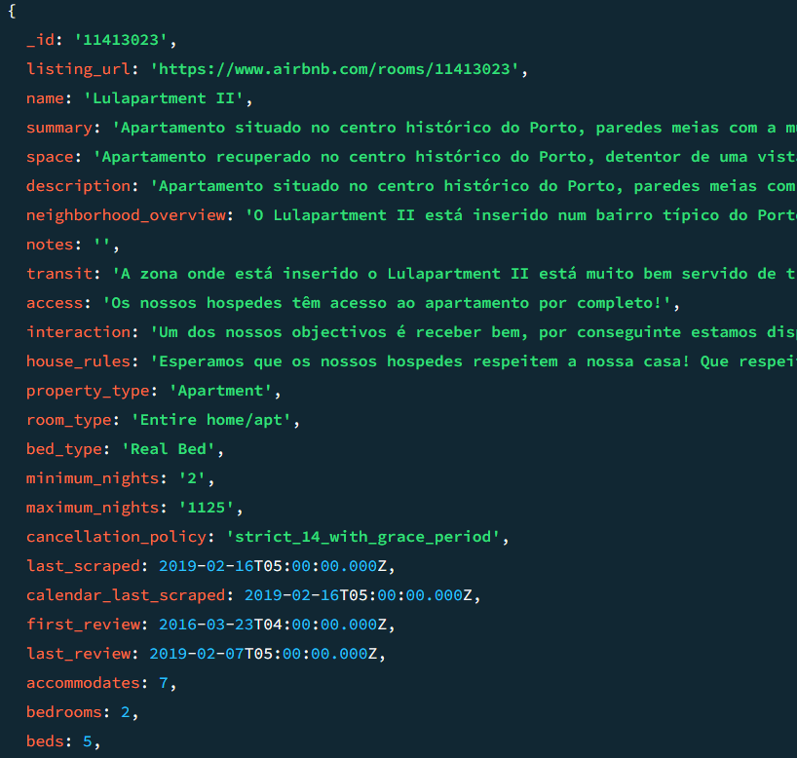

#### 2.

db.airbnbData.aggregate([{$match: {"review_scores.review_scores_cleanliness": {$gte : 9}}}, {$project: {"name" : 1, "summary": 1, "address.country": 1, "price": 1, "_id": 0 }}, {$sort: {"price" : 1}}])

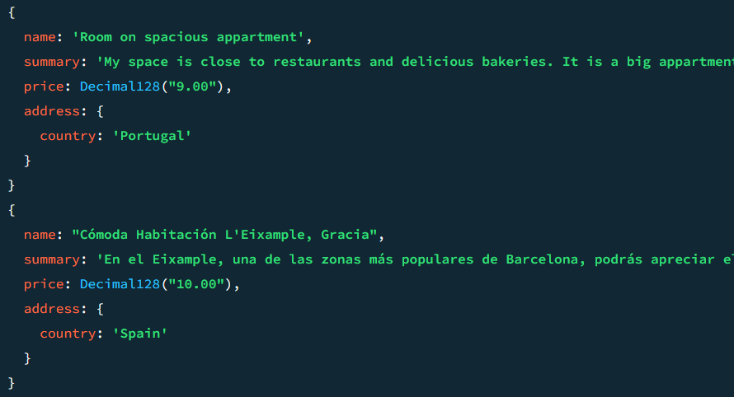

#### 3.

db.airbnbData.updateOne({"description": /.*mountain view.*/}, {$set:{"price": 90}})

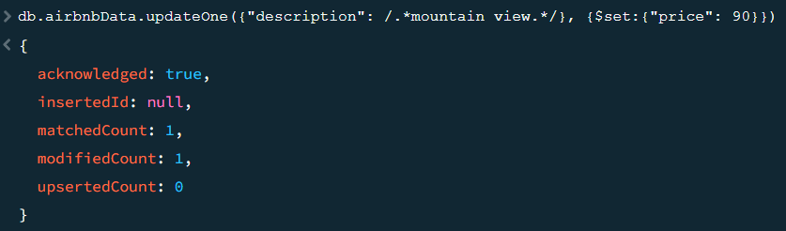

#### 4.

db.airbnbData.updateMany({"address.country": "Turkey"}, {$set: {"isactive": false}})

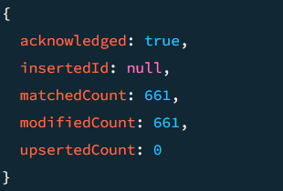

#### 5.

db.airbnbData.deleteMany({"review_scores.review_scores_rating": {$lt: 21}})

